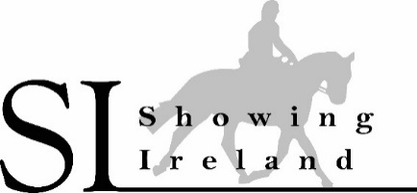2026
Showing Ireland- Points Award Series
Members only
Clonmel Show offers a Mid-Season Double points Bonus for all Riding classes placings from1st to 6th
For Details see www.facebook.com/showingireland

https://bit.ly/4d56iuc

